Blockchain Based Crowdfunding Platform

A project report submitted in partial fulfillment of the requirements for the degree of

Bachelor of Engineering In
Computer Engineering

by

Shruti Patil (9567)
Mrunal Kotambkar (9552)

Ayush Singh (9772)

Under the guidance of

Prof. Monica Khanore (Professor)


DEPARTMENT OF COMPUTER ENGINEERING

Fr. Conceicao Rodrigues College of Engineering, Bandra (W), Mumbai - 400050
University of Mumbai (2023-24)

This work is dedicated to my family.
I am very thankful for their motivation and support.

Internal Approval Sheet

CERTIFICATE

This is to certify that the project entitled "Blockchain based Crowdfunding Platform" is a bonafide work of Shruti Patil (9567), Mrunal Kotambkar (9552),Ayush Singh (9772) submitted to the University of Mumbai in partial fulfillment of the requirement for the award of the degree of Bachelor in Computer Engineering.

Prof. Monica Khanore
Supervisor/Guide

Dr. Sujata Deshmukh Head of Department
Dr. S. S. Rathod Principal

Approval Sheet Project Report Approval

This project report entitled Blockchain based Crowdfunding Platform by Shruti Patil (9567), Mrunal Kotambkar (9552), Ayush Singh (9772) is approved for the degree of Bachelor of Engineering in Computer Engineering.

Examiner 1. ————————————–
Examiner 2. ————————————–

Date: Place:

Declaration
We declare that this written submission represents our ideas in our own words and where others’ ideas or words have been included, we have adequately cited and referenced the original sources. We also declare that we have adhered to all principles of academic honesty and integrity and have not misrepresented or fabricated or falsified any idea/data/fact/source in my submission. We understand that any violation of the above will be cause for disciplinary action by the Institute and can also evoke penal action from the sources which have thus not been properly cited or from whom proper permission has not been taken when needed.

Shruti Patil (9567) (sign)
Mrunal Kotambkar(9552) (sign)
Ayush Singh (9772) (sign)

Date:

Abstract

The Blockchain-Based Crowdfunding Platform presents a cutting-edge approach to crowdfunding by utilizing blockchain technology to overcome the limitations of traditional fundraising models. This platform leverages smart contracts to automate and secure the entire crowdfunding process, ensuring that funds are managed transparently and efficiently without the need for intermediaries. Every transaction, from donations to fund distribution, is recorded on the blockchain, creating an immutable and publicly accessible ledger. This transparency builds trust among donors, as they can track how their contributions are used in real time, reducing the risk of fraud and mismanagement of funds. Unlike conventional crowdfunding platforms, which often charge high fees and have limited accountability, the blockchain-based system significantly lowers costs by eliminating middlemen, thus ensuring that a larger portion of the funds go directly to the campaign creators. Moreover, this platform operates on a decentralized model, allowing global access without regional restrictions, making it easier for anyone, anywhere, to create or support campaigns. The core features of the platform include campaign creation, where users can define funding goals and project timelines, donation processing, which ensures secure, traceable transactions, real-time campaign tracking, and fund allocation visibility, all enabled by the transparency of blockchain technology. By offering these features, the platform empowers campaign creators with greater autonomy and control over their fundraising efforts, while also ensuring that donors can make informed decisions based on clear and verifiable campaign data. The Blockchain-Based Crowdfunding Platform effectively addresses the key challenges of traditional crowdfunding models, such as trust issues, high fees, and limited transparency, offering a more secure, efficient, and inclusive solution for raising funds for various causes and projects on a global scale

Content
Abstract iv
Glossary xi
- Introduction 1
  - Motivation 3
  - Objectives 4
- Problem Statement 5
  - Drawbacks of traditional CrowFunding platform 5
  - Solution To Above Problem 6
- Project Description 8
  - Overview of the project 8
  - Module Description 9
    - Modules 9
    - Architecture Diagram 10
    - Input Design 12
    - Output Design 14
- Implementation Details 16
  - Methodology 16
- Conclusion And Future Enhancements 20
    - conclusion 22
    - Future Enhancements 25

Chapter 1

Motivation

Introduction

The rise of crowdfunding has opened new avenues for individuals, startups, nonprofits, and creators to raise funds from a wide audience. It has been instrumental in bringing diverse projects to life, from product innovation and creative endeavors to urgent medical and humanitarian causes. However, traditional crowdfunding platforms like Kickstarter, GoFundMe, and Indiegogo face significant limitations. These centralized platforms act as intermediaries that control every aspect of the process, often charging high fees that reduce the funds ultimately received by campaign creators. Additionally, these platforms can impose restrictions or censor campaigns based on their policies, limiting creators' freedom and autonomy.

Another core challenge with traditional crowdfunding platforms is their lack of transparency. Donors have minimal visibility into how their contributions are being used, leading to mistrust and hesitation in supporting campaigns, especially those initiated by unfamiliar creators. This lack of accountability can also increase the risk of fund misuse, as contributors have no way of verifying if funds are allocated as promised. Furthermore, centralized platforms are often constrained by regional regulations, making it challenging to achieve true global participation, and restricting access for creators and donors in certain countries.

Blockchain technology offers a solution to these issues through its inherent decentralization, transparency, and security. By recording transactions immutably on a distributed ledger, blockchain can create a crowdfunding environment where intermediaries are no longer necessary, reducing costs and ensuring that all transactions are accessible, traceable, and verifiable. With smart contracts, campaign funds can be managed autonomously and only released when specific conditions are met, thereby increasing trust and accountability. This motivates the development of a blockchain-based crowdfunding platform that leverages these benefits to address the current limitations and enhance the crowdfunding experience for all participants.

Objective

The primary objective of this project is to create a decentralized crowdfunding platform using blockchain technology that provides a transparent, secure, and accessible alternative to traditional systems. Specifically, this project aims to:

    - Eliminate Intermediaries and Reduce Fees: By using blockchain, this platform will enable direct transactions between donors and campaign creators, minimizing fees and maximizing the amount of funds that reach the intended projects.

    - Enhance Transparency and Trust: Through the use of blockchain’s immutable ledger, each donation and transaction will be recorded publicly, allowing donors to verify contributions and track campaign progress in real-time, thereby building trust and encouraging participation.
    - Provide Accountability through Smart Contracts: Smart contracts will automate fund management, ensuring that funds are only released under predefined conditions. This will reduce the risk of misuse and reassure donors that their contributions will be used as intended.
    - Ensure Global Accessibility: By decentralizing the platform, crowdfunding campaigns can be accessed globally, unrestricted by regional limitations. This will enable broader participation and allow individuals from all locations to create or support campaigns freely.
    - Empower Campaign Creators and Donors: This platform will allow creators to have complete autonomy over their campaigns without interference, while providing donors with full visibility of how their funds are being utilized.

Chapter 2

Problem Statement

Drawbacks of traditional CrowFunding platform
    - Lack of Transparency: Traditional crowdfunding platforms do not provide clear visibility into how funds are used after they are collected. Donors often have no way of tracking whether their contributions are being spent as promised, leading to potential mistrust and reduced donor confidence.
    - High Fees and Intermediary Costs: Most centralized crowdfunding platforms charge significant service and transaction fees. These fees reduce the total amount of funds reaching the campaign creators, creating a barrier for smaller or less financially robust projects.
    - Risk of Fund Misuse: With limited accountability measures, centralized platforms often lack strict control over how funds are distributed or spent by campaign creators. This increases the risk of fraud or fund misallocation, further diminishing trust in the platform.
    - Regional and Regulatory Constraints: Centralized crowdfunding platforms are subject to regional restrictions, which may prevent access to crowdfunding services for individuals in certain countries. This limits the global reach and inclusivity of campaigns, creating an uneven playing field for users.
    - Dependence on Centralized Control: Traditional platforms have the authority to censor or terminate campaigns based on internal policies, sometimes leading to abrupt campaign disruptions. Campaign creators must depend on the platform's terms and policies, limiting their autonomy and control over their own projects

Solution To Above Problem
To address these drawbacks, this project proposes a blockchain-based crowdfunding platform that leverages the transparency, security, and decentralization of blockchain technology. This platform will use smart contracts to automate and manage campaign contributions, providing a secure and trustless environment where transactions are transparent, fees are minimized, and regional restrictions are removed.

- Enhanced Transparency: Blockchain’s immutable ledger will record every transaction, allowing donors and campaign creators to view contributions and fund utilization in real-time. This ensures transparency and helps to build trust among

participants.
- Reduced Fees: By eliminating intermediaries, the platform will drastically reduce transaction fees, allowing a larger portion of the funds to reach the campaign creator.
- Automatic Fund Management: Smart contracts will enforce predetermined rules for fund distribution, ensuring that funds are only released when specific conditions are met. This will minimize the risk of fund misuse, as smart contracts will securely handle all transactions.
- Global Accessibility: The decentralized nature of blockchain allows for unrestricted global access, enabling campaigns to reach a broader audience without the limitations of regional restrictions.
- Autonomy for Campaign Creators: By decentralizing control, campaign creators can maintain complete ownership over their campaigns without interference from centralized authorities. This empowers them to manage their campaigns freely while retaining full control over fund distribution.

Chapter 3

Project Description
This blockchain-based crowdfunding platform aims to provide a secure, transparent, and efficient alternative to traditional crowdfunding methods. Using blockchain technology, the platform will allow individuals or organizations to create and manage fundraising campaigns, while offering donors a reliable way to contribute to causes they support. By eliminating intermediaries, the platform ensures that campaign creators receive the maximum portion of raised funds, with reduced transaction fees and enhanced transparency.

The platform leverages smart contracts deployed on the Ethereum blockchain, which automatically manage campaign functions like creating campaigns, accepting donations, and tracking contributions. Each campaign has specific funding goals, timelines, and conditions, all governed by smart contracts that ensure funds are released based on predefined rules, thereby enhancing accountability. Donors can view the progress of campaigns and track their contributions in real-time, creating an environment of trust and openness.

With decentralized control, the platform offers a more inclusive experience by being accessible globally without restrictions. Campaign creators and donors can interact directly, with no need for a central authority to manage transactions or enforce platform policies, empowering both parties to achieve their crowdfunding goals with confidence.

Overview of the project

The project workflow follows a streamlined process, which can be visualized in the flowchart below (textual description of the flowchart is provided for clarity):

    - User Registration: Both donors and campaign creators register on the platform.
    - Campaign Creation: A user initiates a campaign by defining details like the funding goal, campaign description, deadline, and fund utilization rules. This information is processed by the smart contract and saved on the blockchain.
    - Donation Process: Donors can browse active campaigns and contribute to causes they wish to support. Donations are sent directly to the campaign’s smart contract, which securely holds and tracks funds.
    - Fund Management: The smart contract automates fund management. When campaign goals are met or upon reaching the deadline, the funds are released according to the predefined rules set by the campaign creator.
    - Tracking and Transparency: Both campaign creators and donors can monitor the

campaign’s progress. Donors can view their contributions and the overall campaign status through real-time updates from the blockchain.
    - Campaign Closure: Once the campaign is complete (goal met or deadline reached), the campaign closes. Funds are disbursed per the smart contract's terms, or returned to donors if conditions are unmet.

Module Description
The Blockchain-Based Crowdfunding Platform includes four main modules to streamline and secure the crowdfunding process. The createCampaign module enables campaign creators to set up new campaigns by defining funding goals, deadlines, and fund usage plans, with all information stored transparently on the blockchain. The
donateToCampaign module allows donors to securely contribute funds directly to the campaign’s smart contract, with each transaction recorded for full traceability and updated in real-time. The getDonor module offers visibility into donation histories, allowing campaign creators to view contributions while maintaining donor privacy and enabling donors to remain anonymous or receive recognition. Finally, the getCampaign module provides
real-time access to each campaign’s progress, displaying key metrics like total funds raised and time remaining, fostering transparency and informed support.

Modules

createCampaign

The createCampaign function allows campaign creators to initiate a new crowdfunding campaign on the platform. This function enables creators to specify essential campaign details such as the funding goal, campaign duration, and usage plan for collected funds. Campaign creators provide a description of their project, a title, a target funding amount, and a deadline, giving potential donors a clear understanding of the campaign’s purpose and objectives. Once submitted, this information is stored on the blockchain, ensuring transparency and immutability. Additionally, the campaign’s smart contract is deployed automatically, setting predefined rules for fund management and distribution to minimize risks and maximize accountability. This function empowers creators with a transparent, autonomous method to manage their campaigns without interference from intermediaries.

Key Features:
          - Provides options to set flexible or fixed funding goals.
          - Allows upload of multimedia (e.g., images or videos) to enhance campaign appeal.
          - Provides an option for milestone-based funding, where funds are released incrementally based on the completion of certain milestones.
          - Sets an automatic refund to donors if the funding goal is not met by the campaign’s end date.

donateToCampaign

The donateToCampaign function enables donors to securely contribute funds to their chosen campaigns. By sending funds directly to the campaign’s smart contract, this feature ensures that donations are traceable and secure. Each donation transaction is recorded on the blockchain, making the process transparent and protecting donors from potential fraud. The function supports donations in cryptocurrency (such as Ether) and processes transactions immediately, updating the campaign’s funding progress in real-time. Donors receive a receipt or acknowledgment of their contribution, reinforcing trust and providing a digital record of the donation.

Key Features:
          - Enables one-time or recurring donations based on donor preferences.
          - Issues a unique donation ID for tracking and acknowledgment.
          - Ensures transaction security with on-chain verification, eliminating intermediaries.
          - Offers real-time funding updates so donors can instantly see their impact on the campaign’s progress.

getDonor

The getDonor function provides campaign creators and the platform with the ability to view information about specific donors while maintaining privacy standards. This feature enhances transparency by allowing campaign creators to see a record of contributions, helping them understand and appreciate their supporter base. Donor information includes the amount donated, transaction date, and total contributions to the campaign.
While individual donor details are accessible to the creator, certain personal information is protected, ensuring that transparency does not compromise donor privacy.

Key Features:
          - Provides a history of donations from each donor, helping creators analyze donation patterns.
          - Ensures data privacy by limiting access to sensitive personal details.
          - Tracks cumulative donation amounts and displays them to allow recognition of top supporters.
          - Allows donors to remain anonymous if desired, giving them control over their visibility on the platform.

getCampaign

The getCampaign function enables users to access real-time details on each campaign’s progress, enhancing transparency and accountability. Through this function, both donors and potential backers can view key metrics, such as total funds raised, remaining time until the campaign deadline, and current progress toward the funding goal. This function updates automatically with each donation, ensuring accuracy in the displayed data. By making campaign information easily accessible, this feature empowers donors to make informed decisions, knowing that they can track the campaign’s achievements and understand its impact.

Key Features:

          - Provides a detailed progress tracker with visuals (e.g., progress bars) to show the percentage of funds raised.
          - Displays a countdown timer to indicate the remaining time until the campaign deadline.
          - Shows an overview of how funds will be allocated, increasing transparency about fund utilization.
          - Highlights recent donations and provides a leaderboard to encourage community engagement and support for high-performing campaigns.

Architecture Diagram
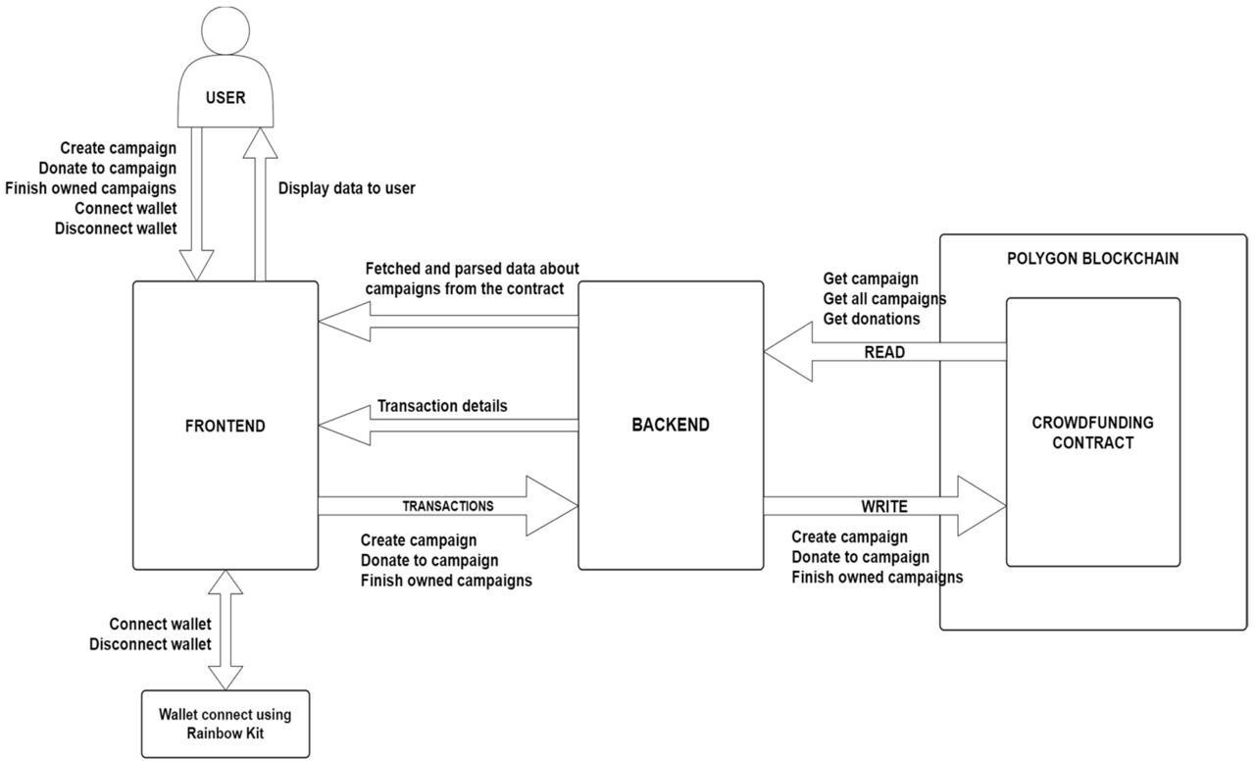

    - Input Design

// SPDX-License-Identifier: UNLICENSED pragma solidity ^0.8.9;

contract CrowdFunding { struct Campaign {
address owner; string title;
string description; uint256 target; uint256 deadline;
uint256 amountCollected; string image;
address[] donators; uint256[] donations;
}

mapping(uint256 => Campaign) public campaigns; uint256 public numberOfCampaigns = 0;
function createCampaign(address _owner, string memory _title, string memory
_description, uint256 _target, uint256 _deadline, string memory _image) public returns (uint256) {
Campaign storage campaign = campaigns[numberOfCampaigns];

require(campaign.deadline < block.timestamp, "The deadline should be a date in the future.");

campaign.owner = _owner; campaign.title = _title; campaign.description = _description; campaign.target = _target; campaign.deadline = _deadline; campaign.amountCollected = 0; campaign.image = _image;

numberOfCampaigns++;

return numberOfCampaigns - 1;
}

function donateToCampaign(uint256 _id) public payable { uint256 amount = msg.value;

Campaign storage campaign = campaigns[_id]; campaign.donators.push(msg.sender);

campaign.donations.push(amount);
(bool sent,) = payable(campaign.owner).call{value: amount}(""); if(sent) {
campaign.amountCollected = campaign.amountCollected + amount;
}
}

function getDonators(uint256 _id) view public returns (address[] memory, uint256[] memory) {
return (campaigns[_id].donators, campaigns[_id].donations);
}

function getCampaigns() public view returns (Campaign[] memory) { Campaign[] memory allCampaigns = new Campaign[](numberOfCampaigns);

for(uint i = 0; i < numberOfCampaigns; i++) { Campaign storage item = campaigns[i];

allCampaigns[i] = item;
}

return allCampaigns;
}
}

Output Design

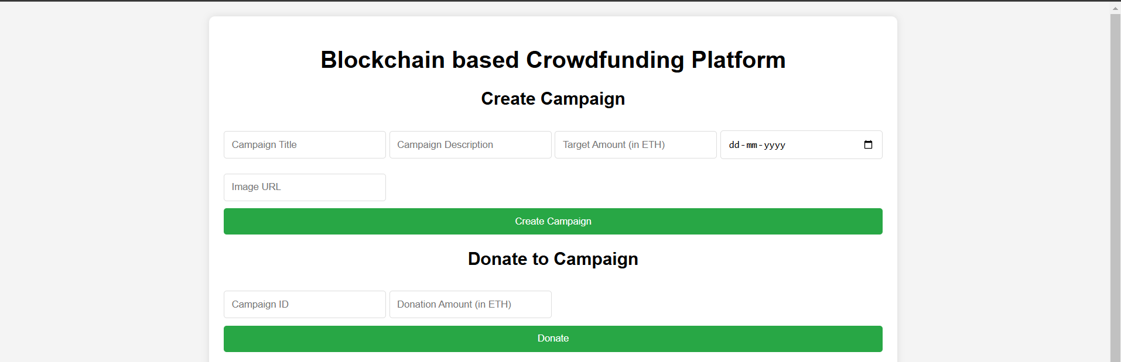
Fig 1.0

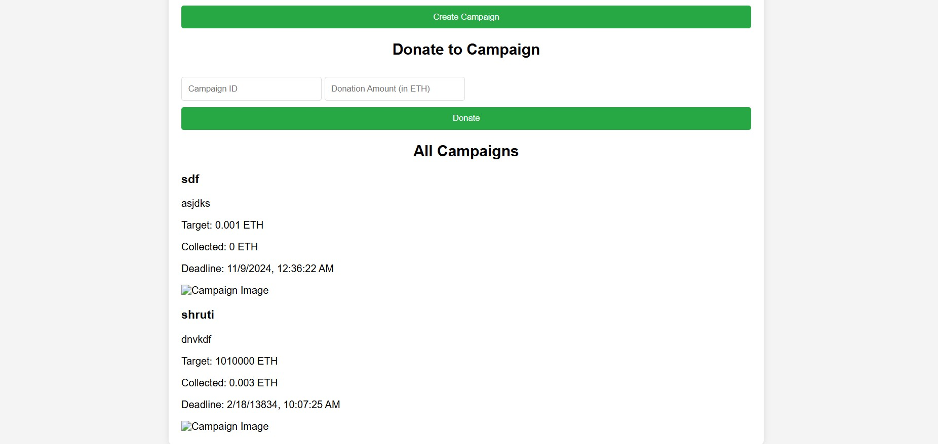

Fig 1.1

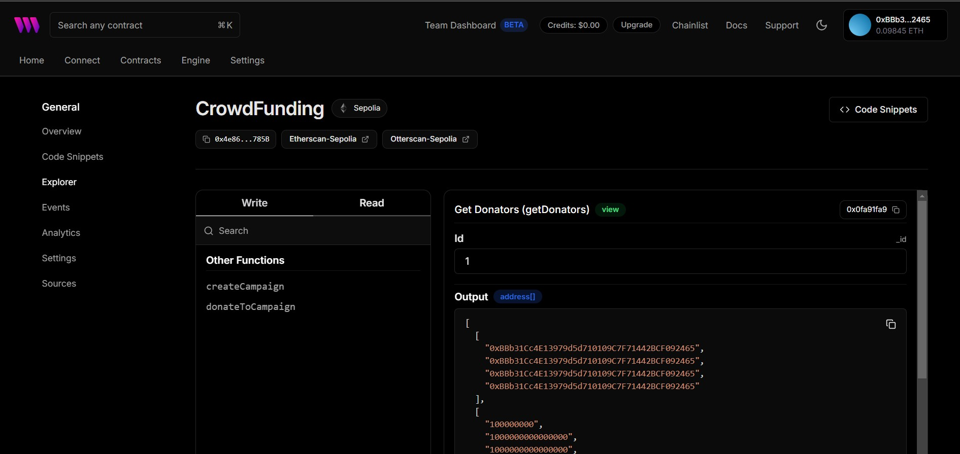
Fig 1.2

Chapter 4

Implementation Details

Methodology

The methodology for developing the Blockchain-Based Crowdfunding Platform involves a structured approach to leveraging blockchain technology for secure, transparent, and efficient crowdfunding. The process includes smart contract development, blockchain integration, user interface design, and deployment, as outlined below:

Requirement Analysis and Design
      - Identify key user requirements, such as secure donations, transparent fund tracking, and easy campaign creation.
      - Design a modular architecture that includes essential components like campaign creation, donation processing, donor and campaign tracking, and fund allocation.
      - Define the specific attributes for each campaign (e.g., funding goal, timeline, and usage conditions) and determine the smart contract’s functions to manage these parameters automatically.

Blockchain and Smart Contract Development
      - Develop smart contracts on a blockchain network, such as Ethereum, to handle campaign creation, donations, and fund disbursement.
      - Implement functions such as createCampaign, donateToCampaign, getDonor, and getCampaign in the smart contracts, ensuring they can securely store and manage funds.
      - Encode business logic into smart contracts, such as automatic refunding if the funding goal is not met, or releasing funds incrementally based on milestones.

Frontend Development
      - Build a user-friendly interface for campaign creators and donors, allowing them to interact seamlessly with the platform.
      - Develop forms and interfaces for campaign creation, donation submission, and real-time campaign tracking, ensuring that users can easily navigate and complete transactions.
      - Use libraries like Web3.js or Ethers.js to connect the frontend with the blockchain, allowing users to interact with the platform through MetaMask or similar wallet integrations.

Backend and Database Setup
      - While the blockchain records all transaction data, set up an off-chain database

(e.g., MongoDB or Firebase) to store non-transactional data, such as user profiles and campaign descriptions, for faster access.
      - Develop APIs to connect the off-chain database with the blockchain, ensuring that relevant data can be displayed to users without compromising the immutability of the blockchain records.

Testing and Security Audits
      - Conduct rigorous testing of smart contracts to identify vulnerabilities, edge cases, and potential exploits.
      - Perform security audits to verify that the smart contracts adhere to industry standards and are resistant to attacks like reentrancy or overflow vulnerabilities.
      - Test the platform’s user interface to ensure smooth functionality across various devices and wallets.

Deployment
      - Deploy the smart contracts on the Ethereum mainnet or an alternative blockchain network suitable for crowdfunding.
      - Deploy the frontend and backend on scalable cloud services (e.g., AWS or Heroku) to handle varying user loads.
      - Configure user-friendly access through a domain and SSL certification to ensure secure connections.

User Feedback and Iteration
      - Gather feedback from initial users and donors to refine the platform’s usability, security, and efficiency.
      - Implement improvements to the user interface, smart contracts, and other system components based on feedback and observed user behavior.

Maintenance and Upgrades
      - Regularly monitor the platform for any security vulnerabilities or potential optimizations.
      - Plan for updates to adapt to evolving blockchain standards, network scalability solutions (e.g., layer-2 solutions), and user needs.

Chapter 5

Conclusion And Future Enhancements

Conclusion

The Blockchain-Based Crowdfunding Platform represents a significant advancement in how crowdfunding is conducted, using blockchain technology to address key challenges like transparency, security, and cost-efficiency. By employing smart contracts, the platform automates fund management and eliminates the need for intermediaries, allowing more funds to reach campaign creators and reducing the risks of fraud or mismanagement. Donors benefit from full visibility into each transaction, ensuring that their contributions are traceable and that funds are allocated as promised. This decentralized approach also enables global access, allowing campaigns to reach a broader audience without regional or currency restrictions.

Through core features like campaign creation, secure donation processing, real-time progress tracking, and transparent fund allocation, the platform not only enhances the fundraising experience for creators and donors but also builds trust and accountability into every project. By overcoming the limitations of traditional crowdfunding, this blockchain-based solution fosters a more inclusive, efficient, and trustworthy environment for supporting diverse causes and projects worldwide. The platform sets a new standard in crowdfunding by blending the innovation of blockchain with the empowerment of individuals and communities, paving the way for future developments in decentralized finance and community-driven fundraising.

Future Enhancements

The Blockchain-Based Crowdfunding Platform has substantial potential for future enhancements that could improve accessibility, functionality, and user engagement. Integrating multi-currency support, including options for multiple cryptocurrencies and stablecoins, would attract a wider global audience, while layer-2 scaling solutions, like Polygon or Optimism, could reduce transaction costs and improve speed, making the platform more accessible to smaller donors. Introducing Decentralized Autonomous Organization (DAO) governance would enable the community to actively participate in decision-making, allowing users to vote on platform upgrades and campaign approvals,

fostering a sense of collective ownership. Milestone-based funding with an escrow system could add accountability by releasing funds incrementally based on project progress, ensuring that campaign creators meet specified objectives. Privacy-enhancing tools, such as zero-knowledge proofs, would protect donor information while maintaining funding transparency, and additional security features like multi-signature wallets would safeguard campaign funds. A reputation and reward system could encourage responsible use of funds and repeated contributions by allowing campaign creators to build credibility and rewarding donors with badges or tokens.

